2021-2022
City View FFA Sheep/Goats Information

Purchase procedures
- Students are welcome to contact and purchase lambs or goats from a sale or breeder directly. Please let Ms. Kasper know when you choose to purchase on your own to ensure an accurate count and assign pens prior to lamb or goat arrival.
- Students can travel to sales or to breeders that Ms. Kasper will be attending for assistance on selecting lambs or goats. The school will not cover the cost of transportation or housing of students while attending buying trips. A parent or guardian is also required to travel with their student while on buying trips.
- Students can provide funding to the chapter's activity account based on their purchasing budget and allow Ms. Kasper to purchase a lamb or goat based on their wants at a sale if the student and their family is not able to be present. If money has not been received by the school prior to the sale, animals will not be purchased. Deadline to provide deposits for purchasing is September 13th

State Validation
- State Validation - Deadline to order validation tags October 20th, 2021.
- Tags cost $25 dollars per animal, please provide a check made out to City View FFA Activity Fund.
- Validation for all County Show only Sheep and Goats will be held Tuesday October 26, 2021.
  - Location: Wichita Falls FFA Barn from 4:00 - 6:00 PM
- Validation for all Major show Sheep and Goats will be held Wednesday October 27, 2021.
  - Location: Iowa Park FFA Barn from 4:00 - 6:00 PM.
Pen rent
- Pen rent will be a one time payment paid at stock show entry night. Funds from pen rent will be used to update the facilities and provide needed items for exhibitors.
- Cost of pen rent will be $50 per head.
Lamb / Goat facility set up
- A mandatory lamb and goat setup will be on September 11th. During this event students will have pens and storage bins assigned. Pens will be set as well as numerous other tasks will be completed to prepare for the year. Students will also be shown the farm procedures and expectations for the year.

Mandatory farm clean up dates
- Students will be required to complete barn clean up (TBD). Checks and prize money from major stock shows will be held until all requirements for the facilities have been met.
- Individual pen spaces must be cleaned prior to the workday.

Estimated Cost breakdown:
- Lamb: ~$500 + Each
- Goat: ~$500 + Each
- Validation tags: $25 each
- Feed: $20-25 per bag
- Supplies: $150
- Shavings: $5 per bag
- Show entries: ~ $30 each per animal plus a fee for admission passes/parking.
- Pen rent: $50 per animal
- Total: ~ $900 +

This total does not reflect the cost of attending the stock show, including hotel stays, transportation cost and dining at the events.

It is the Agriculture Science teacher(s) recommendation to feed multiple animals.
  - Animals are living creatures and can have a multitude of issues including but not limited to;
    - Lameness, sickness, growth rate issues, phenotypically undesirable, and even death that prevents their showing at the desired show.

Dates:
- Farm Set up
  - September 11th
- Stock show entry night
  - October 20th @ 5:00 PM
- Lamb & Goat Validation (County Show ONLY)
  - October 26, 2021 @ Wichita Falls FFA Barn from 4:00 - 6:00 PM
- Lamb & Goat Validation (Major Show)
  - October 27, 2021 @ Iowa Park FFA Barn from 4:00 - 6:00 PM
- Eastland Spooktacular Jackpot Show
  - October 30th
- Wichita Falls: NON- TERMINAL
  - January 5-7
- San Angelo:
  - Market Goats: February 5-6, 2022
  - Market Lambs: February 5-7, 2022
  - Junior Breeding Sheep: February 17-20, 2022
  - Junior Boer Goats: February 6-7, 2022
- Houston:
  - Market Goats March 8-10, 2022
  - Market Lambs March 8-10, 2022
  - Breeding Sheep: February 27-March 1, 2022
- Mandatory Farm Clean up
  - TBD

Lamb and Goat Facility Maintenance & Procedures:
Once we have received the signed feeding contract(s) you will be given a pen assignment, which should be kept clean at the rate of one cleaning per day.

Access to the Lamb and Goat Facility will be from the hours of 6:00AM to 8:00AM and 4:00PM to 10:00PM Monday through Friday. 6:00AM to 10:00PM Saturday and Sunday. All other entries to the facility outside these times will be considered trespassing except for extenuating circumstances.

The use of keycards for anyone other than the student assigned and direct family member is prohibited.

Pen Expectations:
- Pens must be cleaned once a day.
  - The cleaner you keep your pen, the healthier your animals will be and the longer your shavings will last.
- Shavings must be maintained at a reasonable level. (Per Ag teacher’s digression)
  - A Good rule; 6-8 inches in your entire pen.
- We recommend installing a plywood board at the bottom of your pen.
  - These MUST be removable, and NOT be damaging to the pens

Feeding:
I strongly recommend feeding Purina Honor Show Chow & Jacoby Red Tag. I prefer Purina and Jacoby’s feed quality and choices.
Goats:
Start them on Purina Honor Show Chow Impulse Pellets (Gray Purina Bag) ~$22.00
***(Available at Tractor Supply)
> Feed 2-2.5 pounds per day
Lambs:
Start them on Purina Honor Show Chow 15% DX Grower Textured (Purple Purina Bag) ~$25.00
***(Available at Tractor Supply)
> Feed 2.5-3 pounds per day

- Feed rations are individualized to fit the specific needs of animals based on the phenotypical analysis at that given time period.
- Use only a feed measuring scoop (3qt) to feed animal(s)
- Please do not buy feed in bulk, fresh feed is the best feed for sheep & goat projects.
- All feed should be placed into feed containers with lids of 5 gallon buckets and placed into storage containers. No bags should be placed into open storage containers.
- Feed your sheep & goat at the same time every morning and every night! (Within a 30 min window each day)
  - Train your sheep & goat to eat; once they are adjusted and on feed give them 20 minutes to eat, then pull their feeder.

NRS Feed Store  605 Farm to Market 156 Decatur, TX 76234  940-627-3949 | Atwoods Farm & Ranch  2047 TX-11 Loop, Wichita Falls, TX 76306  940-855-9100
Berend Bros  4311 Jacksboro Highway, Wichita Falls, TX 76302  940- 723- 2735 | TSC  2618 southwest pkwy, Wichita Falls, TX 76308  940-696-8850
Berend Bros  19017 US Hwy 281, Windthorst, TX 76389 | Berend Bros  103 West Clay st. Bowie, TX 76230
Gebo’s  3900 Wilbarger St, Vernon, TX 76384  940-552-7631 | Red River Ranch Supply  1331 Cumberland St, Vernon, TX 76384  940-552-8080
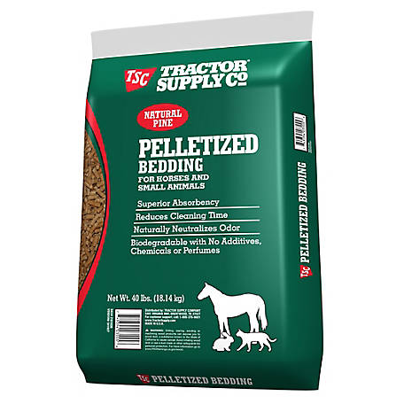

Required Supplies: (The feed stores have a majority of these products)
- Feed trough (Hanging)
- Pelleted shavings 5 bags (Pelleted shavings/horse quality) starting out
($5.29)
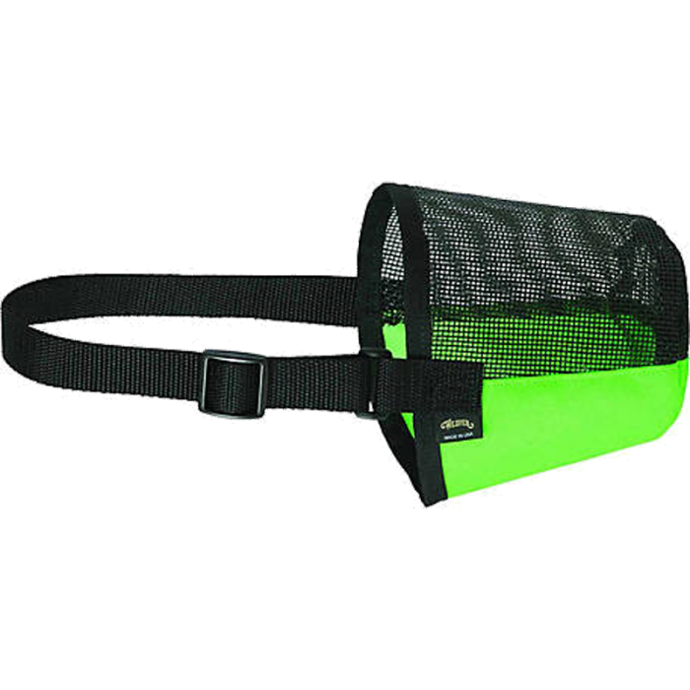
- Feed (depends on the animal)
- Water buckets (20 QT)
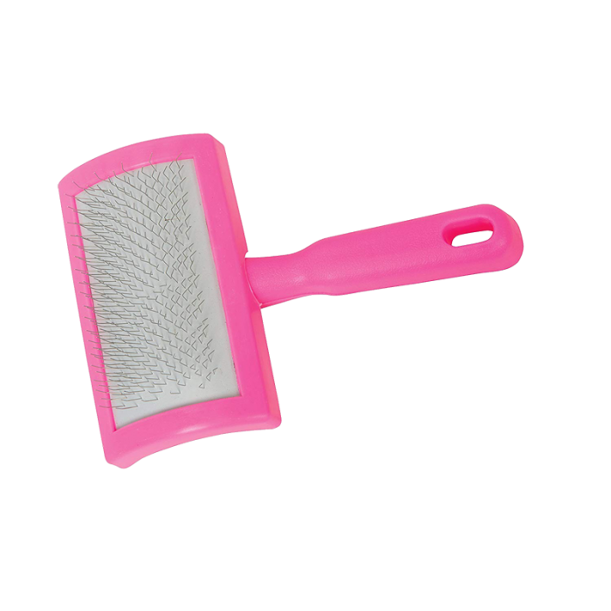
- Lamb & Goat Halters (Prefer the leather rope halter)
- Weaver Leather Sheep & Goat muzzle (~$10.99)
- Weaver leather plastic slicker brush
- Lamb & Goat blankets (For colder months)
- Lamb & Goat socks (For colder months)
- Dollar General box fan (Mount on pens)
- Castration wound spray/Alumisheild (if not already castrated)
- Plywood to line pens
- Horse Fly & Bug spray
- Fungus Fighter

Emergency Contact List

Sheep & Goats
Please contact the Ag teacher between the hours of 8:00am and 9:00pm. If an emergency exists, that needs immediate attention, please contact the vets listed below.

City View High School
Ms. Kasper
Join the Lamb and Goat Show Team Remind by texting @89e6ca3 to the number 81010
Email: kkasper@cityview-isd.net
Join the City View Stock Show Google Classroom: zu4uzi

Vets

Cross Timbers Veterinary Hospital  1403 TX-59, Bowie, TX 76230  940- 872-2161 | Simmons and Harlan Veterinary Clinic  202 Valley View Rd, Wichita Falls, TX, 76305  940-723-4054

